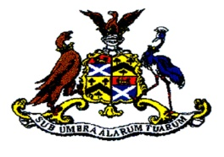

OWHC NEWSLETTER SEPTEMBER 2016
Welcome back to a brand new and hopefully exciting, entertaining and enjoyable season at Medway's most sophisticated and sociable Hockey Club. Like all the clubs in the area, we have no home grown Olympic Gold medallists from Rio, but with the wonderful women's success in winning the Hockey Gold, perhaps the popularity bounce will one day lead to one of our own players emulating this success?!
Since the EGM in March and the AGM in May, your committee has been extremely active, preparing for the coming season. This Newsletter will hopefully give you an idea of what is planned on and off the pitch and get your juices flowing, socially, physically and mentally.
PLAYING ARRANGEMENTS
We are back at the Math for all our home fixtures this season. The pitch has been refreshed which will make better play and the floodlights are due to be upgraded in the next week, with brand new heads and cabling. This work has been an expense and we are grateful to the school for involving the club in the whole process and meeting the upgrade costs, which total around £35,000.
We have established a strong relationship with the school, the Head Eliot Hodges and the Head of PE Simon Downes and we will continue to liaise closely with them and with the OW Mother Club to ensure that the facilities are maintained and developed over the coming seasons. The upgrades to the pitch will pay dividends at training and during matches this coming season and there are plans in place to resurface the pitch at the end of the season. We will remain closely engaged with the school in all of this.
Home games will be played at 12pm, 1:30pm and 3pm. Please ensure you do your bit for your captains by:
- turning up for the meet time promptly.
- assisting with any tasks required at pitchside and in the clubhouse.
- socialising with the umpires and the opposition.
- assisting with preparation of teas and washing up.
- doing all you can to make the day run smoothly.
NEW PLAYING KIT
The order has been placed with our new supplier, Akuma, for playing shirts for all our teams. We are extremely grateful to our sponsors, Cooling Castle Barn and Affinity Apps, for their contributions towards the purchase of the shirts. You will be able to see samples of all the new kit at club day and indeed many of you have already placed orders for shorts/skorts/socks etc. It is worthwhile considering adding new kit to your Christmas lists, if you have yet to place an order. Please note that no kit will be issued without payment upfront. Stocks will be maintained by Neil Thompson and Stuart Gray, for any orders during the season please contact them directly. In due course ordering of equipment will be made via the club website.
For those dedicated historians of the club whom may wish to purchase one of the old playing shirts for posterity, we will arrange a sale of OW "retro" shirts at competitive prices! This will be on a first come first served basis, with proceeds being ploughed back into the club. (£5 each). If you specifically request a shirt worn by the infamous Barry Mackness or Ian ‘chopper’ Harper- these iconic items will cost significantly more at £5.25.
This years’ new shirts will be handed out at the start of each game and MUST be given back immediately after each game to be washed ready for the next fixture.
NEW WEBSITE
We are currently in the process of moving our website over to the Pitchero format, which opens up all sorts of exciting avenues for us in terms of club administration, revenue streams and technology. The domain name will not alter and you can continue to access the current website as normal. Hopefully, we will be able to move over very soon, but we need your help on this please. We want to populate our new website with as much content as possible, so this means any content you can provide us with will be most gratefully received. We are talking old team photos, old news clippings, any memories from our older members and anything you consider that would add value to the site. We will then get to work and look to make our new site a fantastic hub for our club, celebrating our past, present and future.
Anything you have to contribute, please contact Gary Bage or Jeff Doust.
SOCIAL
Please find a rundown of the OWHC social calendar for the coming season, starting with #HockeyFest Club Day- 10th September and culminating in the annual dinner on 8th April 2017.
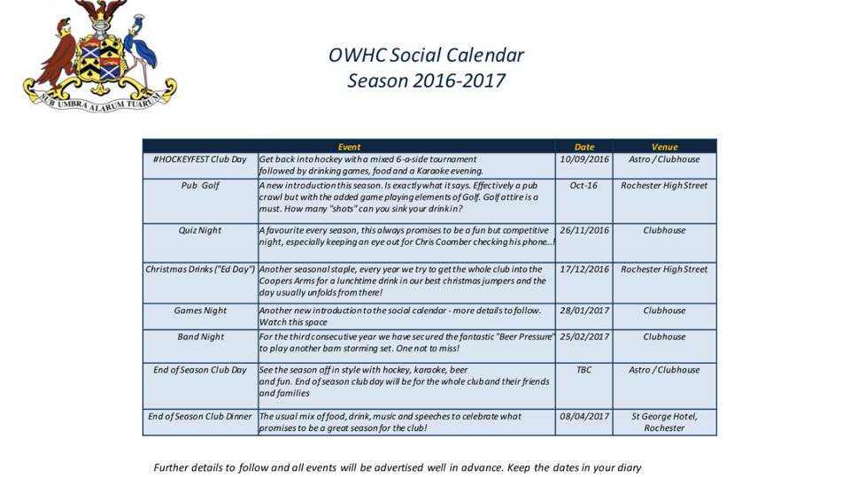
These events contribute much needed revenue for the club and are great fun. Please put these dates in your diary as a MUST!
ANNUAL SUBSCRIPTIONS
As passed at the AGM, here are the subscriptions for the coming season:
MEMBERSHIP TYPE | ANNUAL COST | MONTHLY COST (OCT-MAR INCLUSIVE)
FULL SEASON MEMBERSHIP (ADULT) | £324-00 | £54-00
FULL SEASON MEMBERSHIP (UNEMPLOYED/STUDENT/U18) | £162-00 | £27-00
10 GAME MEMBERSHIP (ADULT) | £228-00 | £38-00
10 GAME MEMBERSHIP (UNEMPLOYED/STUDENT/U18) | £114-00 | £19-00
OCCASIONAL MEMBERSHIP (ADULT) | £144-00 | £24-00
OCCASIONAL MEMBERSHIP (UNEMPLOYED/STUDENT/U18) | £72-00 | £12-00
JUNIOR (U16 - YR 11 AND BELOW) | £nil | £nil

Some points for reference:
- The full season is based on an annual sub of £104-00 and 22 games at £10-00. Anchs is £360-00. At Holcs, you would be paying £486-00. Our subs remain the cheapest in the surrounding area. The slight increase in subs will ensure we are financially sound and able to not just survive as a club but thrive, especially if social events are well supported.
- 10 game membership gives a sub of £104-00, plus 10 games at £12-40 per game. We therefore reward those who are more regularly available, but cater for those who may not be able to play a full season. This is known as the Marc King Option.
- Occasional membership again gives a sub of £104-00, then 3 games for £40-00.
- Once a player has reached the 10 or 3 game mark as per (2) and (3) above and they want to continue to play more games, then we reach an agreement on a further lump sum to pay. For example, if a 10 game membership player reaches the 10 game mark, there are 5 games left and he/she wants to play 4 of those games, we get a lump sum of £40-00 - we would simply apply a £10-00 match fee per game. However, the sum gets paid up front.
- Your will notice (and see below) that we have taken the decision to provide free hockey for anyone under the age of 16 as at 1st September 2016. We are the only club to do this; spread the word. We want to build our future, we don't want our future to fund our present....
- The subscription is to be set up as a standing order and paid on the 6th of each month, October to March inclusive. As ever, the club will consider any extenuating circumstances for individuals. The club account details are as follows: Natwest Bank, Strood Branch, Sort Code 60-21-02 Acc No. 77034120 (Please complete the attached form so we know which payment option you have selected. PLEASE BRING IT WITH YOU TO CLUB DAY !

JUNIOR OFFERING
We have a plan to expand our junior offering over the coming seasons to compete with other local clubs and to grow our club even more.
We are doing what no other club is doing and offering our Juniors free hockey. Again, we are grateful to the generosity of our sponsor Cooling Castle Barn, in allowing us to provide this offering. We are partnering with the Math and reaching out to all primary schools within their catchment area, to advertise our Junior training on Sundays and to grow this to provide a steady stream of talent into our senior Saturday sides. This is going to be a huge and long term undertaking, but it is clear to the committee that we have to do this to secure the future of our club. We know from attendances at the EGM and AGM that you are also keen to secure our future and so we appeal to you all to volunteer for whatever you can do to support our Junior programme. This can be as simple as attending on Sundays to make teas and coffees for the parents in the clubhouse, to undertaking a coaching course and going on to help with the coaching on the pitch.
This is going to be the most important development for our club over the coming seasons and it is important that we gain as much support as possible, we hope you will all be able to contribute to this.
Junior training commences on Sunday 25th September. (10-11.30am) It will cater for all ages from 5-18 so if you know of anyone whose children may be interested in attending for free, then spread the word! If you would like some flyers to pass on to a school or any other target audience, please let Neil know.
If you are still interested in supporting the running of your club but do not currently have a role please let us know. All support welcome .
Key Contacts:
General Club matters – Neil, Jeff or Stuart.
Website – Gary Bage
Annual subs – Neil or Paul P
Training – Neil or James P
Kit – Neil or Stuart
Junior Hockey – Neil
Many thanks
OWHC Committee

Annual Subs Form Season 2016/17

Member Name:

I will be paying my annual subs based on the category below (tick below):
Please note all categories below are based on payment via standing order. If you have an issue with this please speak to Neil or Paul P.

MEMBERSHIP TYPE | ANNUAL COST | MONTHLY COST (OCT-MAR INCLUSIVE) | Tick appropriate box
FULL SEASON MEMBERSHIP (ADULT) | £324-00 | £54-00
FULL SEASON MEMBERSHIP (UNEMPLOYED/STUDENT/U18) | £162-00 | £27-00
10 GAME MEMBERSHIP (ADULT) | £228-00 | £38-00
10 GAME MEMBERSHIP (UNEMPLOYED/STUDENT/U18) | £114-00 | £19-00
OCCASIONAL MEMBERSHIP (ADULT) | £144-00 | £24-00
OCCASIONAL MEMBERSHIP (UNEMPLOYED/STUDENT/U18) | £72-00 | £12-00
JUNIOR (U16 - YR 11 AND BELOW) | £nil | £nil

I confirm that I set up payment via stand order to the OWHC bank account for the 6th of each month, (details below) based on the ticked category above.
Natwest Bank, Strood Branch, Sort Code 60-21-02 Acc No. 77034120

Member Signature:

Date:

